**5. Spring Boot**

1. What is an API?

An API, is referred to as an application programming interface, is a set of protocols that enable different software components to communicate and transfer data.

1. What are http methods?

Defines a set of request methods to indicate the desired action to be performed for a given resource.

GET - Requests the representation of the specified resource. GET requests only retrieve data.

POST – Submits an entity to the specified resource.

PUT - Replaces all the current representations of the target resource with the request payload.

Delete – Deletes specified resource.

1. Create a spring boot application
2. Create a new controller class
3. Add a new end-point to return and string
4. Test the endpoint with postman

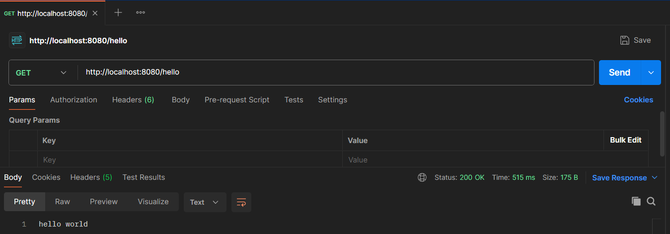

1. Create a Student class (attributes: id, name, date of birth, average)
2. Create a new controller class for students
3. Create a new service class for students
4. Add an endpoint to get list of students
5. Add an endpoint to get a student with id
6. Add new endpoint to create a student
7. Run mongodb as a docker container
8. Insert student received to endpoint created in step 12 to database
9. Extend step 10 and 11 to query data from database
10. Add an endpoint to delete a student with id.
11. Delete the student with id from database
12. What are http status codes

http response codes indicate whether a specific http request has been successfully completed.

1. Briefly explain the meaning of following status codes

200, 201, 301, 400, 401, 403, 404, 405, 500, 501, 502, 503, 504

**100 – 199 Informational responses**

**200 – 299 Successful responses**

200 – The request succeeded.

201 – The request succeeded and new resource was created as a result. This is typically the response sent after post requests or some put requests.

**300-399 Redirection messages**

301- The URL of the requested resource has been changed permanently. The new url is given in the response.

**400-499 Client error responses**

400 – The server cannot or will not process the request due to something that is perceived to be a client error (Bad request)

401 – Unauthorized. Client must authenticate itself to get the requested response.

403 – Forbidden. Client does not have access rights to the content, that means it is unauthorized so the server is refusing to give the requested resource. Unlike 401 here the client identity is known to the server.

404- Not found. The server cannot find the requested resource. This means in the browser, the URL is not recognized. In an API, this means endpoint is valid but the resource does not exist.

**500 – 599 Server error responses**

500- Internal server error. Server has encountered a situation it doesn’t know how to handle.

501 – Not implemented. The request method is not supported by the server and cannot be handled. (methods servers required to support are GET and HEAD)

502 – Bad Gateway. Server while working as a gateway to get a response needed to handle the request got an invalid request.

503 – Service unavailable. Server is not ready to handle the request. Causes are server that is down for maintenance or overloaded.

504 – Gateway time out. Server cannot get a response in time.

1. Using docker-compose run spring boot application and mongodb
2. Create new branch “spring-boot-app-v1” and push the project you created
3. Add your codes and answer sheet to a directory named “spring-boot-basic-training-v1” and push it to your training github repository
4. Create a pull request to main branch and assign it to your trainer